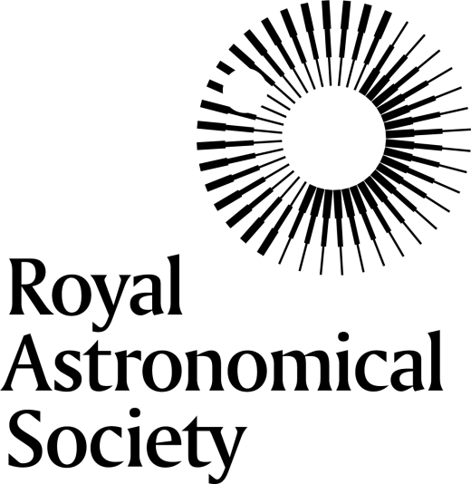

Service Award Winners

The Service Award is to honour individuals who, through outstanding or exceptional work, have promoted, facilitated or encouraged the sciences of astronomy or geophysics and developed their role nationally or internationally.

Year | Astronomy | Geophysics
2024 | Ian Robson | Ian McCrea
2023 | Charles Barclay
2022 | Donald Kurtz | Farideh Honary
2021 |  | Ian Crawford
2020 |  | Kim Burchell
2019 | Donald York | Kathy Whaler
2018 | Mark Cropper | Matt Taylor
2017 | Derek Fry | Richard Harrison
2016 | Alan Wells | Peter Styles
2015 |  | Lidia van Driel-Gesztelyi
2014 |  | Mark Lester
2013 |  | Mike Hapgood
2012 | Paul Murdin
2010 | Francisco Sanchez | Frank Lowes
2009 | Arnold Wolfendale | D. Kerridge
2008 | Guenther Eichhorn
2007 |  | Aftab Khan
2006 | Brian Marsden (both A&G)
2005 | Guy Hurst | Alan Douglas
2004 | Ian Corbett

